**Project Planning Phase**

**Project Planning Template (Product Backlog, Sprint Planning, Stories, Story points)**

|  |  |
| --- | --- |
| Date | 06 November 2023 |
| Team ID | NM2023TMID08291 |
| Project Name | Project – Estimation of business project |
| Maximum Marks | 8 Marks |

**Product Backlog, Sprint Schedule, and Estimation (4 Marks)**

|  |  |  |  |  |  |  |
| --- | --- | --- | --- | --- | --- | --- |
| **Sprint** | **Functional**  **Requirement (Epic)** | **User Story**  **Number** | **User Story / Task** | **Story Points** | **Priority** | **Team**  **Members** |
| Sprint-1 | Registration | USN-1 | As a user, I can register for the application by entering my email, password, and confirming my password. | 2 | High | PALANISELVAM |
| Sprint-1 | Possibilities Checking | USN-2 | As a user, I will receive confirmation email once I have registered for the application through out from customer reviews | 1 | High | VISHWA |
| Sprint-2 | Data Cleansing | USN-3 | As a user, I can pickup the collections from any dataservers | 2 | Low | SANJAY |
| Sprint-1 | Accessbility | USN-4 | As a user, I can register for the application through Gmail | 2 | Medium | ALAM |
| Sprint-1 | Login | USN-5 | As a user, I can log into the application by entering email & password | 1 | High | DILEEP |
| Web user | Dashboard |  |  |  |  |  |

**Project Tracker, Velocity & Burndown Chart: (4 Marks)**

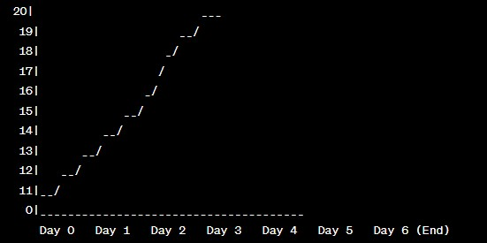

|  |  |  |  |  |  |  |
| --- | --- | --- | --- | --- | --- | --- |
| **Sprint** | **Total Story Points** | **Duration** | **Sprint Start Date** | **Sprint End Date (Planned)** | **Story Points**  **Completed (as on**  **Planned End Date)** | **Sprint Release Date (Actual)** |
| Sprint-1 | 20 | 6 Days | 24 Oct 2022 | 29 Oct 2022 | 20 | 29 Oct 2022 |
| Sprint-2 | 20 | 6 Days | 31 Oct 2022 | 05 Nov 2022 |  |  |
| Sprint-3 | 20 | 6 Days | 07 Nov 2022 | 12 Nov 2022 |  |  |
| Sprint-4 | 20 | 6 Days | 14 Nov 2022 | 19 Nov 2022 |  |  |
|  |  |  |  |  |  |  |
|  |  |  |  |  |  |  |
|  |  |  |  |  |  |  |
|  |  |  |  |  |  |  |

**Velocity:**